Deen Dayal Upadhyay Kaushal Kendra
Study Material
For
B.Voc (BPO)
Semster-IV
Nomenclature: E-Typewriting (English)
Paper Code :(BBPO-404)

Author:
Ms. MamtaGuglani
Commerce Department

Santan Dharam College (Lahore), Ambala Cantt

Paper: (BBPO-404)
E-Typewriting (English)
Maximum Marks: 100 External: 80
Time: 3 hours Internal: 20

Note: Examiner will be required to set NINE questions in all. Question Number 1 will consist of objective type/short-answer type questions covering the entire syllabus. In addition to the compulsory question there will be four units i.e. Unit-I to Unit-IV. Examiner will set two questions from each Unit of the syllabus.

Student will be required to attempt FIVE questions in all. Question Number 1 will be compulsory. In addition to compulsory question, student will have to attempt four more questions selecting one question from each Unit. All questions will carry equal marks.

Unit I
Introduction to e-Typewriting: What is e-Typewriting, Importance of learning e-Typewriting, Types of Keyboards – Physical Keyboard & Virtual Keyboard, Wireless & Wired Keyboard, Standard and Multimedia Keyboard. Basics of Computers, Characteristics, Advantages, Disadvantages of Computers.
Unit II
Starting and shutting down a Computer and Printer: Steps to switch on and switch off a computer; Difference between Turn Off, Stand By, Hibernate, and Restart. Keyboard Layout (QWERTY & INSCRIPT, QWERTY Keyboard Layout: General Keys, Function Keys, Lock Keys, Lock Indicators (Lights), Cursor Control Keys, Numeric Keys, Numeric Keypad. INSCRIPT Keyboard Layout: Importance of INSCRIPT Keyboard, Concept of using standard QWERTY keyboard with INSCRIPT overlay.
Unit III
Touch Typewriting Ergonomics: Layout, Correct sitting posture, Position of Keyboard, Mouse and Monitor. Methods of Typewriting: Touch Method of Typewriting Sight Method of Typewriting (Advantages and disadvantages of both the methods) Positioning of fingers on the Keyboard according to touch method of Typewriting.
Unit IV
Use of Touch Typing Tutor Software (Online and Downloadable; Freeware and Open Source Software) for practice. Importance of Speed and Accuracy. Safety and Security of Data.
Suggested Readings
- Goel, Anita. Computers fundamentals. Pearson Education India.
- Miller, Michael. Absolute beginner’s guide to computer basics (5th edition).
- Rajaraman. Fundamental of computers. Prentice Hall India Pvt. Ltd.
- Sarvanan. Computer fundamentals with MS Office applications. Scitech Publications.
- TheComputerManual.com, www.free-ebooks.net/ebook/Computer-Basics - E-Book
INTRODUCTION

The ability to type and use a computer keyboard and mouse are essential if you want to be ableto communicate well in the world today. As reading and writing skills improve, it’s a great ideato include computer and typing training. And the great part about this curriculum is it includesexercises that will at the same time help you improve your reading and writing!Although learning to write by hand is essential, there are benefits to using a computer for someof your lessons. With typing, there’s no need to worry about your handwriting and editing ismuch easier. Plus, learning to use a computer will be a great boost to your confidence and self-esteem.“But, wait,” you say, “I don’t know ANYTHING about computers!” No problem! Thiscurriculum includes resources, activities, example exercises, and lessons that will be fun waysfor you to become more confident in your computer and typing skills.So, whether you’ve used a computer before or not, you’ll find an appropriate level within theselessons to jump in and begin. A few of the resources begin by teaching what all the keyboardkeys actually do. Plus, you’ll learn to effectively manipulate computer windows and dialogueboxes using the all-important mouse.

So … ready to get started? Let’s go . . .

Getting Started
To begin with, discuss your strengths and weaknesses regarding typing and computer use. Haveyou ever used a computer? If so, to what extent? Do you have typing experience? Do you haveaccess to a computer so you’ll be able to do homework if assigned?

Although the best way to learn is to dive right in to a particular task, or maybe even play a
computer game or two, if you are very new to a computer keyboard and mouse you may need
step-by-step help to get started. Begin here by learning about finger placement and keyboard
keys.

UNIT-1

E-TYPEWRITING

LET’S START

Computers have moved into every corner of our daily lives. Computers areat work in departmental stores, homes, offices, hospitals, banks, theatersand even coffee shops. They have become so fundamental to our modernsociety that without them, our economy would grind to halt. In the last fewdecades, computers have completely altered business practices all aroundthe world.We are living in information age and with the concept of Virtual and PaperlessOffice prevalent in today’s office environment, all the office procedures i.e.mail handling, processing, storage and retrieval of data, etc. are handled bycomputer. Therefore, it has become imperative to use computers in the mostefficient and effective manner. One of the ways to optimize the usage ofcomputers is to learn and type on computer keyboard speedily and accurately.e-Typewriting followed with Touch Methodfamiliarizes with the mechanismof accurate and speedy typewriting on a computer so that more work can bedone with less energy and time.

OBJECTIVES

At the end of this lesson, you will be able to:
•know the meaning and importance of e-Typewriting
•differentiate between typewriting and e-Typewriting
•understand the basics of computers
•practise the procedure of starting and shutting down of computer
•enlist various types of storage devices
•explain the various ways of safety and security of data in a computer

E-TYPEWRITING – MEANING AND IMPORTANCE

The art and technique of typing on computer is known as e-Typewriting.
As computers have become an integral part of our professional and personallives, acquiring of computer skills has become as important as reading andwriting skills. It has become increasingly essential for everyone to usecomputer keyboard efficiently so as to make optimum use of computers.Mastery of the keyboard particularly becomes much more important forprofessionals who spend a lot of time on working with computers. Operatingthe keyboard efficiently also gives a great boost to one’s confidence and self-esteem besides providing effectiveness to the jobs on hand. Though themanual typewriters have been replaced with computers yet the need to acquirehigh typing speed by the users cannot be under-emphasized.

TYPEWRITER V/S COMPUTER
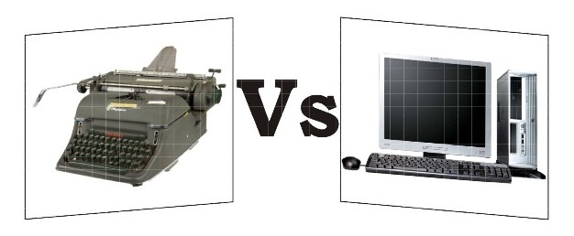

e-Typewriting :: 3Computer is much more powerful than a manual typewriter. As compared totypewriting on a manual typewriter, e-Typewriting has the followingadvantages:

•e-typewriting reduces the fatigue of the computer operator and output is
increased.
•Feather touch and not hard strike is required to operate the keys of
computer keyboard.
•Since the carriage moves automatically to the next line, there is no need
for the hands to leave the keyboard.
•There is uniformity of typed matter. So, quality of work is better.
•Editing of text is easy. There are cut, copy, paste, redo, undo etc. options
for the purpose.
•One can justify margins in e-Typewriting due to word wrap feature of
computer which was not possible on a typewriter.
•Different type fonts and font sizes are available on computer.
•Spelling and grammatical errors can be easily detected and corrected.
•Automatic centralization of headings and underscoring features are
available on computer.
•Special mathematical and other signs can be typed.
•No extra strain is required for making multiple copies.
•Typed matter can be saved and used for future reference.
•Coloured print of the matter can be taken.
•With the help of internet, typed material, graphics etc. can be e-mailed
to other users.
•e-Typewriting has brought about revolution in the concept of Paperless
and Virtual office.

KEYBOARD – Meaning and Importance

Keyboards are input devices. An input device is any peripheral or computer
hardware that’s used to control signals to your computer. Keyboards,scanners and even gaming controllers are all considered input devices orperipherals. This is the most common input device which has an arrangement of buttons or keys. It is like a typewriter. Internally, a keyboard contains a matrix of switches and a keyboard controller. When you press a key, its switch gets pressed and when you release a key, its switch gets released. Through pressing & releasing of switches, keyboard controller generates a scan code.
Keyboards come in all shapes and sizes. Gone are the days of simply usingthe keyboard that comes standard with your desktop computer. Keyboardstoday offer a selection of features for home or office use—such as integrated dual speakers that provide stereo-quality sound, media consoles that let you play and navigate through your music and specially internet browser controls for an improved internet surfing experience.

Advantages of Keyboard

•Most reliable way of inputting data.
•Reliable way of inputting text and numbers.
•Available in variety of format.

Disadvantages

• Not useful for entering some specific type of data e.g. picture, diagrams,
voice, video etc.
• Very slow while accessing menu options or selecting various objects
on screen.
• Not much useful for enlarging or changing sizes of windows on screen.

CATEGORIES OF KEYBOARDS

Keyboards are divided into three main categories based on input method.
These categories are:
• Wired keyboards
• Wireless keyboards
• Virtual Keyboards
- Standard Keyboard
- Multimedia Keyboard

WIRED KEYBOARDS
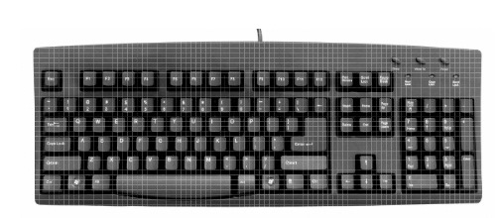

A wired keyboard means there is a wire connecting your keyboard to yourcomputer. At the end of the wire is a USB (Universal Serial Bus) or PS/2(Personal System/2) plug that goes into a port on your computer. Wiredkeyboards are extremely reliable—there is little that could go wrong withthis direct connection. The one drawback of having a wired keyboard is that your distance is limited between the keyboard and your computer; you can only have your keyboard as far from your desktop or laptop as the wire length. Also, wires can clutter your desktop. If you are looking for something sleek, you might consider a wireless keyboard.

WIRELESS KEYBOARDS

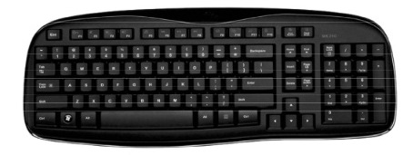

A wireless keyboard works just like a wireless mouse; you plug a receiverinto one of the USB ports on your computer. The receiver then sends a signal to your battery-powered keyboard. Keep in mind, wireless USB keyboards do have a limited range and some must be within the line of sight of your receiver, depending on the type of signal it uses. Also, if your cordless keyboard starts acting sluggish, it probably requires new batteries.Wireless keyboards present a specific benefit to the consumer. First, wireless USB keyboards reduce wire-clutter on your desk. Also, you aren’t tied to your desk—you can type from your couch, your kitchen table or even while seated on your living room floor! Some keyboards come in a set with a wireless keyboard and mouse. This is an added bonus since computer use is no longer limited to your office.

VIRTUAL KEYBOARD

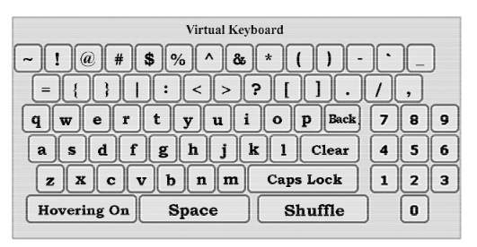

When entering confidential data (such as a user name and password at anonline store) with a normal keyboard, there is always a risk of this data being intercepted by spyware. Such programs record keystrokes and in this way read information that is entered with a normal keyboard. This information is then sent to the intruder through the Internet.Functions of different keys on the Virtual Keyboard

Caps Lock: This key can be used to enter upper case if the password consists of capital letters.

Back Space : This key will clear the last character entered in the passwordfield.

Clear: This key will clear all characters entered in the password field byvirtual keyboard.

Tab: This key is visible only for change or forced change of password. Thiskey can be used to enter values in the next field.

Advantage of a Virtual Keyboard

The Virtual Keyboard is designed to protect your password from malicious“Spyware” and “Trojan Programs”. Use of Virtual keyboard will reduce therisk of password theft.

Disadvantages of a Virtual Keyboard

Tactile Feel: One benefit of a physical keyboard is the ability to feel the keys pushing down. Although this is not necessary, it does help some users determine when a key is struck with an appropriate amount of force. The virtual keyboard does not provide the same tactile feel and can take someadjustment for those composing letters, documents or chatting online.

Space: On a device with enough screen space to accommodate a full sizekeyboard, it can be difficult to see the document being typed on thescreen. A full-size QWERTY keyboard uses a large amount of the screenspace to accommodate two hands while typing. This limits the abilityto proofread a document or letter while typing. Only a fraction of theletter or document will be visible above the virtual keyboard.
Dirty Screens: While a physical keyboard can become dirty with crumbs, dust and debris, the screen usually remains clean. When using a virtual keyboard and touch-screen technology, the screen will inevitably become smudged and dirty. Over time, the device’s screen can become difficult to see and read.

Ergonomics: Using a virtual keyboard on a larger tablet style device can cause ergonomic issues for the user. The device must be propped at an angle to keep wrists in the proper position for comfortable typing. The usermust also look directly down on the screen while typing and this canlead to neck injury or neck fatigue if typing for a long period.

STANDARD KEYBORD
Standard alphanumeric keyboards have keys that are on three-quarter inch centers (0.750 inches, 19.05 mm) and have a key travel of at least 0.150 inches (3.81 mm). Desktop computer keyboards, such as the 101-key US traditional keyboards or the 104-key Windows keyboards, include alphabetic characters, punctuation symbols, numbers and a variety of function keys. The internationally common 102/104 key keyboards have a smaller left shift key and an additional key with some more symbols between that and the letter to its right (usually Z or Y). Also the enter key is usually shaped differently. Computer keyboards are similar to electric-typewriter keyboards but contain additional keys, such as the command or Windows keys. There is no standard computer keyboard, although many manufacture imitate the keyboard of PCs. There are actually three different PC keyboards: the original PC keyboard with 84 keys, the AT keyboard also with 84 keys and the enhanced keyboard with 101 keys. The three differ somewhat in the placement of function keys, the control keys, the return key, and the shift key.

MULTIMEDIA KEYBOARD
A multimedia keyboard is designed to make it simple for the user to access often-used programs. There are special keys used to access the Internet, music, and other frequently used programs such as email. A typical example contains buttons that control various computer processes, such as turning on the computer's power, putting the CPU to sleep, and waking it up again. The web browser keys on a multimedia keyboard should be familiar to most Internet users. Back, forward, stop, and refresh buttons are usually present, along with buttons to access bookmarked favorites, search, and whatever web page the user has set up as their browser's preference as the initially loaded homepage. Most of these keyboards also have a hotkey for the computer's calculator program, a well as a key to open the computer's access screen for navigation of applications and files. Volume control is another handy function that many such keyboards possess. The keys for lowering and raising the computer's volume are clearly marked with easily recognizable speaker icons. This is especially useful for controlling music programs, and often songs can be played and paused, scanned forward and backward, and skipped using the appropriate buttons. There may also be a mute key available.

BASICS OF COMPUTERS

A computer is an electronic device that consists of hardware and software tostore, retrieve and process data. The term hardware describes the physicalparts of computer which we can physically touch or see such as CPU, monitor,keyboard, mouse and other physical parts. Software is set of instructions thatinstructs the hardware what to do. It guides the hardware how to accomplisheach task. One of examples of software is Operating System.An Operating System (OS) is the most important software that runs on acomputer which manages all other software and hardware units on thecomputer. It also allows to communicate with the computer. In simple words,we can say that it is an interface between user and hardware. Examples ofOS are: DOS, Microsoft Windows 9x, Windows 7, Macintosh, Linux, UNIXetc.

Note:At the time of buying a Software, ensure that it must be registered and havea Licence Number. It helps to prevent unauthorised use of software andtakes care of seller’s rights.

Characteristics of Computer

The basic characteristics of computer are given as under:
•Speed:A computer can perform Millions of Instructions Per Second(MIPS) which means the computer processes an instruction inmicroseconds and nanoseconds.
•Storage: Enormous amount of data can be stored electronically inconsiderable less space, and retrieved in a fraction of time.
•Accuracy:A computer’s high-speed processing is also accompaniedby highly accurate performance.

•Versatility:It can perform different types of logical taskswhich areprogrammed according to specific needs ofdifferent fields.

•Diligence: Computers are highly consistent unlike human beings whohave limited physical and mental abilities. They do not get bored or feeltired. Like humans, they do not suffer from lack of concentration afterdoing a monotonous job. A computer can tirelessly perform the similaroperations hundreds of times in exactly the same way and does not makemistakes due to boredom.

Advantages of Computers

Some of the advantages of computers are given as under:
•Computers can automate various tasks, once they are given logicalsequence.

•Computational and calculation works have become easy to perform,thus saving a lot of energy and time.
•With Storage of data and files, the information can be used for futurereference.
•Automatic correction of spellings and grammar to get error-free resultsis possible with computers. Formatting of documents is another optionavailable to us.
•Use of Internet to access any information is one of the most importantadvantages of computers .
•Communication networks are possible.
•It is a source of entertainment and widely used by the film industry.
•Due to on-line filling of forms, services of various service sectors likebanking, insurance, education etc. can be accessed.
•Paperless Office and Virtual Office co ncept being enjoyed byprofessionals has enhanced overall efficiency and effectiveness of work.
•A computer can work on several languages once programmed to do so.

Disadvantages of Computers

As a machine, a computer also has some limitations. Some of these limitationsare listed below:
•A computer cannot work on its own, i.e., if we do not give particularinstructions to perform a job, it cannot generate information on its own.
•A computer does not have any self decision-making capability. It takesdecisions according to the programmed logical steps provided to it.
•Though computers store data and provide security to the data but thereis always a fear of theft and misuse of data.
•It may have health risks and e-waste has negative impact on environment.
•Additional efforts are required to learn the use of computers and developsoftware. Change of software, if needed, also requires lot of efforts.
•Indiscriminate use of computers for communication may threatenpersonal bonding in an organization.

UNIT-2

Computer Start and Shutdown

START
Locate your computer's power button
The power button symbol resembles a circle with a vertical line through it. Power button location will vary from computer to computer, but you can typically find the power button in one of the following locations:

- Laptop - Left, right, or front side of the housing. Sometimes the power button also appears as a key near the top of the keyboard, or as a button in the area above or below the keyboard.

- Desktop - On the front or back of the CPU, which is the box-shaped piece of hardware to which your computer screen connects. Some iMac desktops have the power button on the back of the monitor or the keyboard instead.

Press the power button
You don't need to hold down the power button to turn on the computer. You should hear the computer's internal fan and disk drive begin spinning; after a few seconds, your computer's monitor will also light up and display either the start-up screen or the login screen, depending on whether the computer was off or sleeping.

- For a laptop, you'll first need to open the screen by pulling it up and away from the laptop's housing.

- If your desktop computer doesn't turn on, try pressing your monitor's power button as well. It may be the case that your computer is on but the monitor is not.

SHUT DOWN – In case of MS Windows, go to Start button on Taskbar (the
circle with the windows logo on it), go to the right and select shut down.
Sometimes computers do not start by following the prescribed procedure.
At this time, one has to check all cables to ensure that they are not loosely
connected and plugs are tight.

DIFFERENCE BETWEEN TURN OFF AND STANDBY

When you click Turn Off Computer, Windows XP shows 4 options to shut down your computer.
- Stand By
- Turn Off
- Restart
- Hibernate
Most people understand Turn Off and Restart as they’re frequently used. Where people get confused is between Stand By and Hibernate. The main differences lie in power consumption and data storage.

Windows Stand By Maintains a Fast State of Readiness
When you hear the term “stand by” you think of a resource that is ready to go once called. The concept is similar in Windows. Your computer returns to a state of readiness when you press a key or the power button. The time it takes your PC to resume or shut down is seconds.Your machine recovers quickly as your data is stored in RAM. The slower part is waking up the peripherals. Although your machine is in “stand by” the power has been cut to items such as your hard drive and monitor. You’re running your machine in a very low power mode, but it is still on. This mode can be useful if you’re on a notebook and need to conserve your battery while you step away.
If you have a notebook, you wouldn’t want to keep your computer in this state for more than several hours. The first issue is that even though you’re in a low power consumption state, you’re still using power. The bigger reason is once your power goes, so does your data.The big drawback to Stand By is you run the risk of losing whatever data you were working on if the power goes out. As a precaution, you might want to save the data before putting your computer in this mode or use Hibernate.

Windows Hibernate Takes a Longer Term Approach
An option with a longer perspective is hibernate. Like Stand By, you can recover your place. The big difference is that your PC has shut down and is not pulling power. Another difference is that your data is saved to your hard disk and not RAM. This makes it a safer, but slower option for shut down and resume.
Hibernate will save your desktop and open files to a special Windows file called hiberfil.sys. This large file usually resides in your root folder (c:hiberfil.sys). The file size closely matches how much RAM your PC has installed. If you have 2 gigs of RAM on your notebook, you’re going to have to give up 2 gigs of hard disk space. Note: You can delete the hiberfil.sys file only if you disable hibernate.When you press your power button, Windows will start and open the files you were using. The process is not instantaneous as with Stand By, but gets you to the same place. You may find this option is faster than rebooting, as Windows doesn’t have to do things such as detecting your hardware.

Where is the Hibernate Option?
Hibernate doesn’t show by default. Your manufacturer has to have included the functionality and it needs to be enabled. Even then, there is a trick to seeing this option. Usually, when you turn off your computer you see the following dialog.
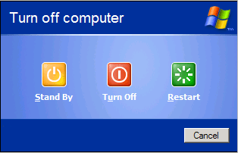
If you hold down your Shift key, you’ll see the Stand By option changes to Hibernate.
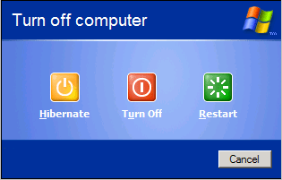
If you still can’t see the option, you should check your Power Options Properties in your Control Panel.

Creating a Windows XP Power Scheme
Most Windows XP systems allow you to set various power options. This is ideal for notebook users who wish to conserve power after a certain period of inactivity. It’s also useful for desktop owners who wish to conserve power. As example, you might want to create a profile that first puts your computer into Stand By mode and then goes into Hibernate after another time.
To create a Power Profile in Windows XP,
- From the Start menu, select Control Panel
- Select Performance and Maintenance
- Select Power Options.
Your system should display the Power Options Properties dialog with various tabs. The number of tabs will vary based on your manufacturer and if you have a UPS. Notebook systems have extra settings so you can set a scheme for when you’re using direct power or batteries.
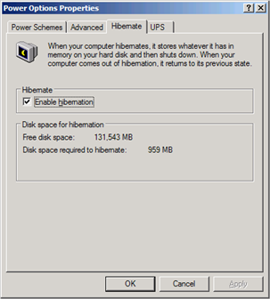
- Click the Hibernate tab. Check the box if you wish to enable this feature.
- Click the Power Schemes tab.
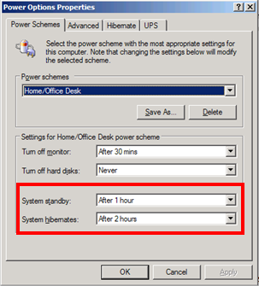
- Set your options to suit your needs. If you’re on a notebook, make sure that your hibernate time is less than your battery time. Otherwise, your battery will drain before the option can kick in.
- Click OK.
We may be use to cheap and abundant energy, but there is little need to keeping your computer fully powered. Microsoft and various hardware vendors have improved the power management systems. The bigger question is whether you should use Stand By, Hibernate or both. If you run into problems, Microsoft troubleshooting article on hibernating
PRINTER
A printer is an external hardware output device that takes the electronic data stored on a computer or other device and generates a hard copy of it. For example, if you created a report on your computer you could print several copies to hand out at a staff meeting. Printers are one of the most popular computer peripherals and are commonly used to print text and photos. The picture to the right is an example of an inkjet computer printer, the Lexmark Z605.
- Types of printers
- Printer interfaces
- History of various printers and how they work
- Related printer pages.
- Computer printer help and support.

TYPES OF PRINTERS
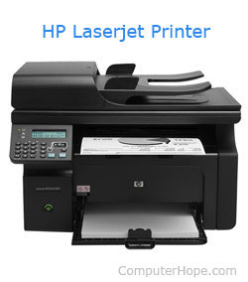
Below is a list of all the different types of computer printers. Today, the most common printers used with a computer are Inkjet and Laser printers.
- 3D printer
- All-in-one (AIO) printer
- Dot matrix printer
- Inkjet printer
- Laser printer
- LED printer
- Multifunction printer (MFP)
- Plotter
- Thermal printer

Printer interfaces
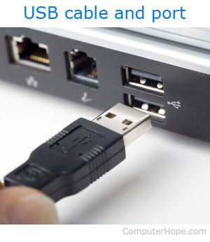
There are a few different ways a printer can connect to and communicate with a computer (referred to as interfaces). Today, the most common connection types are by USB cable or via Wi-Fi. Below is a full list of cables and interfaces used to connect a computer to a printer.
- Cat5
- Firewire
- MPP-1150
- Parallel port
- SCSI
- Serial port
- USB
- Wi-Fi

History of various printers and how they work
Mechanical printer
The first mechanical printer was invented by Charles Babbage, for use with the Difference Engine, which Babbage developed in 1822. Babbage's printer utilized metal rods with printed characters on each rod to print text on rolls of paper that were fed through the device.
Dot matrix printer
The first dot matrix printer was created by IBM in 1957. However, the first dot matrix impact printer was introduced by Centronics in 1970. To create letters and images, the print head, which contains pins, sits over an ink ribbon. This ribbon rests just above a piece of paper. As the print head moves across the ribbon (usually horizontally), the pins are pressed into the ribbon to imprint ink onto the page (similar to a typewriter). As these pins print a series of dots, you can see where this printer got its name. See our dot matrix printer page for further information and related links.
Inkjet printer
While inkjet printers started being developed in the late 1950s, it wasn't until the late 1970s that they were able to reproduce decent digital images. These higher quality inkjet printers were developed by multiple companies, including Canon, Epson, and Hewlett-Packard. Inkjet printers are similar to dot matrix printers in that the images they create are composed of dots. However, the dots on an inkjet printer are shot onto the page rather than using a ribbon and pins. Furthermore, an inkjet printer's dots are much smaller, and their print speed is faster. See our inkjet printer page for further information about this printer.
Laser printer
In the early 1970s, Gary Starkweather invented the laser printer while working at Xerox by modifying one of their mode 7000 copiers. However, it wasn't until 1984 when Hewlett-Packard introduced the HP LaserJet that laser printers became more widely available and affordable. The following year, Apple introduced the Apple LaserWriter, which introduced PostScript technology to the printer market. Laser printers are a more complex than their predecessors. For information on how they work, check out our laser printer definition.
3D Printer
The 3D printer was created by Chuck Hull in 1984. 3D printers work by taking a digital blueprint of an object and reproducing it layer-by-layer using various materials such as plastic and metal alloys. See our 3D Printer definition for further information about this printer.

How to setup and install a computer printer
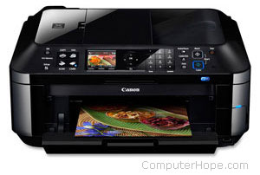
A computer printer does not work until you install the included drivers and software. If you have lost the CD for your printer, you can download the drivers for your printer and use the drivers to install your printer. A listing of printer manufacturers and links to their associated drivers pages are on our printer drivers page.

Connecting the printer to the computer
Connect the printer to the computer either using a USB cable, parallel port cable, or SCSI cable and then connect the power plug to a power outlet. Today, most all home computer printers are using a USB cable similar to the example picture.
Tip: If this is a network printer, connect the printer to a wireless network or the RJ-45 connection.
Note: A laptop computer works the same way as a desktop and can use any of the above connections if they are available.
Note: Smartphone and tablet users must have a printer that can connect to devices wirelessly or over the Internet to print.

Setup printer and install software
Every printer should come with the software used to install a printer in Windows or your operating system.
- After everything has been plugged in turn the computer on.
- Insert the CD that came with the printer. If the CD does not automatically start, open My Computer, double-click on the CD drive, and then click the Setup or Install file. If you have downloaded the drivers, run the downloaded setup file.
- Follow the installation wizard and once completed your software is installed.
- Test the printer to make sure it is working.
Computer with no CD drive
If your computer does not have a disc drive or you lost the CD you can download the software for your printer from the manufactures printers driver page. Once the drivers have been downloaded you can run the file to install the drivers.

Installing a printer only using the drivers
If you only want the printer to be installed and none of the extra software programs you can only install the printer driver by following the steps below.
Tip: A listing of printer drivers and software is on our printer drivers page.
Note: If you have installed the printer doing the above steps these steps should not be necessary unless you encountered errors.
- With the printer connected and on open the Control Panel.
- In the Control Panel double-click the Printers or Printers and Fax icon.
- In the Printers window, click the Add a printer icon.
- After completing the above steps, you should see the Windows Printer Wizard. Click Next to start the wizard.
- Next, you have the choice of installing a Local or Network printer. If the printer is connected to your computer choose Local printer attached to this computer and click Next.
- When prompted for the location of the printer drivers, browse to the directory of your drivers or point it to the printer CD.

Testing the printer
After the printer is installed, you can use Windows to print a self-test page to help verify the printer is working.
Microsoft Windows users
- Click Start, Settings, and open Control Panel.
- Double-click the Printers or Printers and Fax icon.
- Right-click on the Printer you want to test and click Properties. If you do not see your printer, your printer is not installed.
- In the Printers Properties window, click the Print Test Pagebutton.
- If the printer can print a test page, your printer is installed and setup properly. However, if you are unable to print in other programs the program you are attempting to print from has issues.

How to print a document, picture, or another file
Each file and document, as well as the programs used to open them, are different. Therefore, we are only able to give a basic overview of steps in printing. These steps are a general guideline and may not apply to the document or file that you are trying to print. That being said, many programs have adopted a standard method of printing.
Note: Before proceeding, make sure your printer is turned on and has been installed and configured.

Steps on printing a document, picture, or another file
Tip: Before trying any of the steps below, a fast way of printing a file in most programs is to use the keyboard shortcutCtrl+P on a PC or Cmd+P on an Apple computer.
- Open the document or file you want to print.
- At or near the top of the program window, look for a print icon that should resemble any of the below icons.
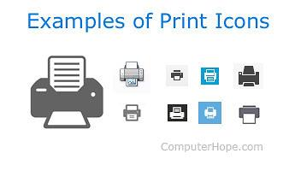
As can be seen in the picture above, each of the icons should resemble a printer with a piece of paper coming in from the top or bottom.
- OR -
- Open the document or file you want to print.
- In the top portion of the window of the program or browser you are using, the File menu is typically located in the upper left-hand corner of the screen.
- If you have just clicked File, select Print from the drop-down menu.
- Either option opens a Print properties window or automatically starts printing the document or file.
- If the Print properties window is showing, you can specify additional printing options, such as how many copies you want or which specific pages you want to print. Once you've selected the options, click Ok or Print to start the printing process.

Printing selected text or picture from an Internet web page
For printer-friendly pages like Computer Hope, when you print a page, all navigation menus and other non-important sections are automatically removed. For those times you come across a web page that is not printer-friendly or if you only want to print a section of a page or picture, follow the steps below.
Tip: If there are several sections of text or images you want to print at the same time, it may be easier to copy the text or picture from the web page and then paste it into a document. Once everything has been gathered into a single document, you can print that document to print everything at once.

Print a selection of text
All browsers support the ability to print selected text. Highlight the text you want to print on the page and press Ctrl+P on a PC or Cmd+P on an Apple computer to open the print options. In the print options window, select "Selection only" or "Selection" from the available options.
Note: You may need to click More settings or Advanced options before seeing the selection option.
Print only a picture from a web page
To only print a picture contained on a web page, we recommend opening the picture by itself. To do this, right-click on the image and select "Open image in a new tab" or "Open image." Once the image is displayed by itself, press Ctrl+P on a PC or Cmd+P on an Apple computer to start the print process. You can try these steps now on the image below.

When I print it is saving to a file and not printing
A computer is capable of having multiple printers installed on a computer. Some printers that may be installed may act as a save to file or PDF function, which save anything printed to a file instead of a printer. If you've installed any program with these capabilities, your default printer may have been changed. If you want to print, make sure you are selecting the correct printer before starting to print. You can also change the default printer so that the correct printer is selected each time you print.

I cannot print because other print jobs are waiting to print
If the printer is not turned on, online, or ready, all print jobs are sent to a print queue and wait until the printer is ready. Once the printer is ready, all available jobs should resume. If the jobs do not resume, either the printer is not ready, or there is another problem. You can test for a problem by either restarting the print job canceling all other print jobs and then trying again.
Note: If you are trying to print to a network printer, you cannot print unless the printer is online. If the printer is turned off, not connected to the network, or there is another network related issue, the printer is shown as offline.

If you are still unable to print
Some programs (often only older ones) may also use the keyboard's print screen or prtscrn key to print. If your program does not work with the previous steps, try pressing this key to print the document or file.
Finally, if you're able to locate the print option, but it is grayed out, or you receive an error, it is likely you have problems with the printer or its drivers.
Note: In some rare situations a program may not have a print option. Although not typical, if you believe your program cannot print try copying what you want to print and paste what you want to print into another program that can print.

KEYBOARD LAYOUTS

QWERTY: The QWERTY (pronounced KWEHR-tee) keyboard is the standard typewriter and computer keyboard in countries that use a Latin-based
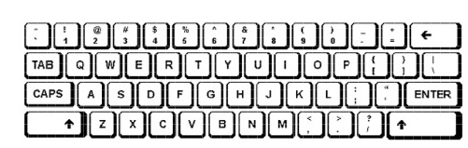

QWERTY refers to the first six letters on the upper row ofthe keyboard. The key arrangement was devised by Christopher LanthamSholes whose “Type-Writer,” as it was then called, was first mass-produced in 1874. Since that time, it has become what may be the mostubiquitous machine-user interface of all time. The QWERTY arrangement was intended to reduce the jamming of typebars as they moved to strike ink on paper. Separating certain letters from each other on the keyboard reduced the amount of jamming. In 1932, August Dvorak developed what was intended to be a faster keyboard, putting the vowels and the five most common consonants in the middle row, with the idea that an alternating rhythm would be established between left and right hands. Although the Dvorak keyboard has many adherents, it has never overcome the culture of learning to type on a QWERTY.

IN-SCRIPT (Indian Scripts)

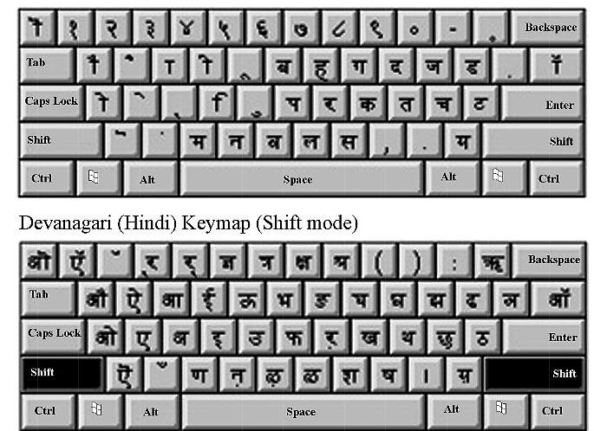

Script is basically a way or mechanism of inscribing. One script maybe used for writing different languages and one language may be writtenusing different scripts. For e.g. Devnagari script is used for writing languages like Hindi, Marathi, Konkani, Santali, Dogri, Sindhi, Kashmiri. At the same time, languages like Konkani are written using Roman script and Devnagari script, santali language can be written using Devnagari script as well as ol-chiki script.

Explore

- Keyboard can also be categorized according to the interface :
- AT keyboard Interface,
- PS/2 Keyboards and USB keyboards.

KEYBOARD LAYOUT (Types of Keys)

INTRODUCTION

In order to enhance operational skills in the use of computers, knowledge of
efficient and effective keyboarding skills and typing ergonomics has become inevitable today. With consistent, sincere efforts and controlled environment, we can master keyboarding skills and acquire high speed. Keying data into the computer quickly and accurately, thus, becomes easy.
In the previous lesson, you have studied about various methods of typewriting. Now, we know that with Touch Method of Typewriting, there is no need to search the key while typing and one has to move only the finger which is needed to strike a key. In this lesson, we will study about various types of keys, typing ergonomics and positioning of fingers on the keyboard according to Touch Method of Typewriting and use of typing software for learning keyboarding skills.

OBJECTIVES
After going through this lesson, you will be able to:–
•know the different types of keys available on computer keyboard
•understand typing ergonomics
•identify positioning of fingers on the keyboard
•carry out speed development exercises to acquire high speed
•practice on typewriting tutor software

LEARNING COMPETENCIES

After going through this lesson, you will be able to attain the following
competencies:–
•familiarize yourself with different types of keys on computer keyboard
•operate the computer keyboard speedily and accurately
•key data on numeric keypad efficiently
•develop ability to use typing tutor software

TYPES OF KEYS

Though there are several input devices viz. mouse, touch screen, character/ voice recognition etc. used for giving input to the computer, yet the use of keyboard is the most common method adopted for input of data into a computer.
Commonly, a computer has a keyboard that looks like a typewriter keyboard. However, a computer keyboard contains additionally certain keys which are also used to give commands to the operating system of a computer. A computer keyboard contains the following types of keys:

• Alphanumeric Keys
These keys contain letters and numbers on the keyboard. These keys
are:A-Z for alphabets, and 0-9 for numbers.

• Punctuation keys
The keys used for inserting various punctuation marks are period (full
stop), comma, semicolon, brackets, apostrophe, parenthesis etc. Also,
it includes all of the mathematical operators such as the plus sign,
minus sign, and equal sign.

• Special keys
Understanding the keyboard also means learning thespecial functions of certain keys. Commonly used special keys areexplained as under:

Ctrl Key : The full form of Ctrl is Control. This key is used incombination with other keys. For example, Ctrl+S to save a document.

Alt Keys : The full form of Alt is Alternate. It is used like a controlkey. You depress Ctrl+Alt+Del simultaneously when you want to getout of computer as the application on which you are working is heldup or muddled up.

Arrow Keys : There are normally four arrow keys to move the cursor- up, down, right or left. The Arrow Keys can also be used in conjunction with the Shift or Alt keys.
Function Keys : Normally located as first row from the top, these keysare marked as F1 to F12.

Enter Key : Also called Return Key. It is used to move the cursor tothe beginning of the next line and give line spaces.

Backspace Key: This key deletes the character just left to the cursorposition and hence moves the cursor to that position.

Delete (Del) Key: This key deletes the character to the right at thecurrent cursor position or the selected objects.

Shift Keys : There are two shift keys provided on both sides of thekeyboard for typing capital letters and upper case signs. (Lower casecharacters are small letters and characters shown on the lower leftside of a key while upper case characters are capital letters andcharacters shown on the upper left side of a key).While following Touch Method of Typewriting, if any upper casecharacter letter of the left hand side is to be typed, then right side shiftkey is to be depressed with the little finger of the right hand and ifright hand upper case characters are to be typed, then the left handshift key is to be depressed with the left hand little finger.

Caps Lock : It is a toggle key that helps in typing many uppercasecharacters.

Esc Key : It means Escape which is used to exit (or escape) fromprograms and tasks and send special codes to different devices.

• Numeric Keypad
Numeric keypad is used when enormous numeric data is to be entered. This keypad, just like a simple calculator, is normally located on the right hand side of computer keyboard. It contains numbers 0 to 9, addition (+), subtraction (–), multiplication (*) and division (/) symbols, a decimal point(.) and Num Lock and Enter keys. Numeric keypad may also work on dual mode. On one mode, it represents numbers and on the other mode, it contains various keys like arrow keys, page up, page down, etc. Num
Numeric Keypad

Lock is provided to switch between the two modes. Usually, the keyboard
of Laptop do not have numeric keypad.
• Home Keys
As already explained in the previous lesson, home keys and guide keysare used in Touch Method of Typewriting. On a QWERTY keyboard,the eight fingers of both the hands rest on Home Keys during the courseof keyboard learning. Alphabets ASDF are home keys for the left handand; (semi-colon) LKJ for the right hand. The fingers are trained tomake the correct movement to other keys and each finger returningimmediately to its respective home key after it has depressed thecorresponding key in any other row.

• Guide Keys
On a computer keyboard, keys ‘F’ and ‘J’ are called guide keys for leftand right hand respectively. Both contain a small raised tangible markwith the help of which the touch typist can place the fingers correctlyon the home keys. On a typewriter, the two keys ‘a’ and ‘(semi-colon) ;’ are called guide keys which are depressed with left and right hand little fingerrespectively. Initially we place the little finger on these keys thus guidingthe placement of rest of the fingers on home keys. A diagram showing the position of fingers of bot.

UNIT-3

TYPING ERGONOMICS

Typing Ergonomics are the factors which provide logistic support and comfort to do a typewriting job efficiently and effectively. They are important as the position adopted when operating a computer keyboard has an important bearing on the degree of accuracy and speed one is able to attain and maintain. Some of these factors included are given as under:

Sitting Posture: While operating computer keyboard, you should sitstraight, slightly bending your neck forward. Be comfortable and there should be no tension in the body. The lower portion of your back should touch the lower portion of the back rest of the chair. Both of your feet should touch the floor. When typing, you should not cross your legs. There should be a distance of approx. 15 cms between two knees. Knees should be bent at 90 degree angle.

Position of Hands: Your forearms should be at level with the keyboardand palms down. Keep your wrists straight. The shoulders and elbows should hang naturally. The elbows should neither touch the body nor be too far away from the body. Elbows should also be bent at 90 degree angle.

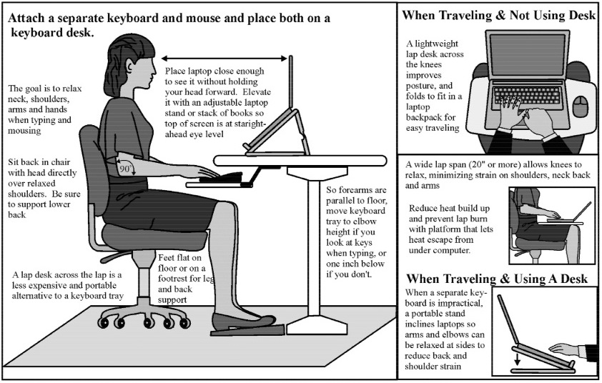

Monitor Placement:The close proximity of your monitor may lead to headaches, tense neck muscles, eyestrain etc. You should not bend your neck while working on the monitor and the upper border of screen should be at eye level. The distance of screen from the user depends on the size of screen. Approximate distance is 60 cms for 17 inches screen.

Mouse and Keyboard Placement: Keep your keyboard and mouse close together. The user should have an approximate distance of 20 cms from the keyboard, which will help in smooth and effortless operation of keyboard Same height of keyboard, mouse and elbows helps the users to work comfortably.

Chair and Table: Both computer user’s chair and table should be adjusted to an optimal height. Chair of computer user must be supportive of his lower back. Upholstery of chair should have a non-slip material. Keyboardand vibrating devices like printers should be on separate tables. Computertable should also have sufficient space for your legs. Once an ergonomically correct workstation is ensured, typewriting effectivelyand efficiently becomes a natural phenomenon without causing unnecessary fatigue.

Placement of Matter to be Typed: In case you need to copy matter while typing, it may be either placed left or right to the keyboard preferably on a Copy Holder which has a sloping surface.

BALANCE BETWEEN MOVEMENT AND STABILITY
To avoid occupational hazards, it is important that you maintain balance between movement and stability of eyes, fingers, body, hands, back and shoulders.

POSITIONING OF FINGERS ON THE KEYBOARD
As typing is equivalent to pen or pencil now-a-days, mastery of computer
keyboard has become obvious. Mastery typewriting skills means to attain
necessary knowledge and skill of keyboard operation by correct positioning
of fingers. Here, we will discuss the Touch Method of Typewriting on QWERTY Keyboard Layout.

Specimen of QWERTY Layout is given as under:In the Home Row Approach, also called Horizontal Approach, all the eightfingers of both the hands rest on Home Keys during the course of the keyboard operation. The fingers are trained to make the correct movement to the other keys in such a way that each finger return immediately to its home key after it has depressed the corresponding key in any other row.The thumb of right hand is used to operate Space Bar. The keyboard learning process starts from the second row (Home Row) followed by the Third Row (Upper Row), First Row (Bottom Row) and the Fourth Row (Number Row). The fingers of both the hands have to operate the keys allotted to them on each row. It must be remembered that each finger has to operate only the key allotted to it. The process of allocation of different keys to different fingers on different rows is discussed below: Allocation of keys to fingers on the Second Row (Home Row)

Why is Typing Skill Important?
Gone are the days when typing skill is only important for transcriptionists and data entry tasks. In today’s world, everybody find themselves sitting in front of a computer and keyboard for one reason or the other. It could be surfing the internet, chatting or even typing a project or report. Without the right typing skill, you will have difficulty in carrying out these activities. Typing accuracy and typing speed are important skills that everyone should have. However, just like every important skills, it is not an instant thing. You need to learn and perfect it. This treatise will take you through the importance of typing skill. The most important importance of typing skill is that it helps to make you more productive. This is because it reduces the time it takes you to complete tasks and as such increase the amount of tasks or assignment you can take on or alternatively make you spend less time sitting at a computer. When people talk about productivity, they often talk about how to do things faster so that they can save time that can be used to do other things. This way they can accomplish more in the same amount of time. The reason why good and fast typing skill is important for productivity is simple: nowadays we spend more and more time on the computer. We use computer to communicate with our friends, create new documents, play games, and find information. We spend increasing share of our time with the computer. And despite the rise of other ways of interaction (like speech recognition), the main way of interacting with the computer is still typing so you need to type to tell the computer what you want.An impeccable typing skill helps to improve and increase accuracy as well as decoding efficiency. For professionals, this will make employers reward faster typists with more work or better-paid positions. Also, as with writing skills development, if you aren’t looking at your keyboard, you can focus more on the tone and subject of your writing. Typing can be learnt by kids as young as 6 years old so far their hand can fit perfectly on the keyboard. This helps them to build and increase literacy development skill and mold them to become excellent writers because it enhances the speed with which kids type, meaning they have more time to spend thinking about ideas and improving the flow of a piece.Finally, having a good typing skill help to improve your health because if you spend a significant amount of time at a desk, in front of a computer sitting and typing, it can take a toll on your body. Achy shoulders, stiff neck and sore wrists are some of the side effects of poor posture and bad computer habits. With good typing skill, you learn the proper way to sit and cultivate better habits, your arms and shoulders will relax and your energy levels will stay consistent throughout the day.
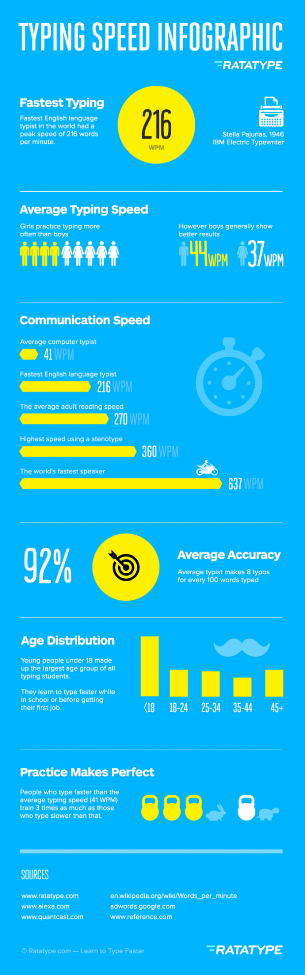
MOUSE
The mouse gives you control over your computer. With the mouse in your hand you cause the onscreen arrow to move around your computer display. It is based on the “point and click” philosophy. You move your mouse to a point where you want something to happen, then you click to make that event take place. Sometimes you click once. Sometimes you click twice. And sometimes you hold down the mouse while your event is happening.
Most mouse devices give you two opportunities for clicking. There are both right and left areas to depress. The left area is generally used for issuing commands to your computer. To access special menus (known as context sensitive menus) use the right portion of your mouse.
A computer mouse is a handheld hardware input device that controls a cursor in a GUI and can move and select text, icons, files, and folders. For desktop computers, the mouse is placed on a flat surface such as a mouse pad or a desk and is placed in front of your computer. The picture to the right is an example of a desktop computer mouse with two buttons and a wheel.
- Who invented the mouse?
- What are the functions of a mouse?
- How has the mouse increased the computer usability?
- Types of computer mice?
- Computer mouse ports
- What are the parts of a computer mouse?
- What does a laptop use for a mouse?
- What does a smartphone or tablet use for a mouse?
- What hand should I use to control the mouse?
- How can I use or practice using the mouse?
- Mouse vs. mice or mouses
- Is "mouse" an acronym?
- Related mouse pages
- Computer mouse help and support

Who invented the mouse?
The mouse was originally known as the X-Y Position Indicator for a Display System and was invented by Douglas Engelbart in 1963 while working at Xerox PARC. However, due to Alto's lack of success, the first widely used application of the mouse was with the Apple Lisa computer. Today, this pointing device is on virtually every computer.

What are the functions of a mouse?
Below is a list of each of the computer mouse functions that help a user use their computer and gives you an idea of all of the things a mouse is capable of doing.
- Move the mouse cursor - The primary function is to move the mouse cursor on the screen.
- Open or execute a program - Once you've moved the cursor to an icon, folder, or other object clicking or double clicking that object opens the document or executes the program.
- Select - A mouse also allows you to select text or a file or highlight and select multiple files at once.
- Drag-and-drop - Once something is selected it can also be moved using the drag-and-drop method.
- Hover - Moving the mouse cursor over objects with additional hover information can help discover the function of each object on the screen. For example, hover the mouse over the hover link to see an example.
- Scroll - When working with a long document or viewing a long web page you may need to scroll up or down which can be done using the mouse wheel or clicking and dragging the scroll bar.
- Perform other functions - Many desktop mice also have additional buttons that can be programmed to perform any function. For example, many mice have two side buttons on the thumb portion of the mouse the button closest to the palm can be programmed to go back on web pages.

How has the mouse increased computer usability?
By using a computer mouse, the user doesn't have to memorize commands, such as those utilized in a text-based command line environment like MS-DOS. For example, in MS-DOS a user would have to know the cd command and dir command and type the commands on the keyboard to navigate to a directory (folder) and view the files inside. Whereas a Windows user only has to double-click to open a folder and see its contents.

Types of computer mice
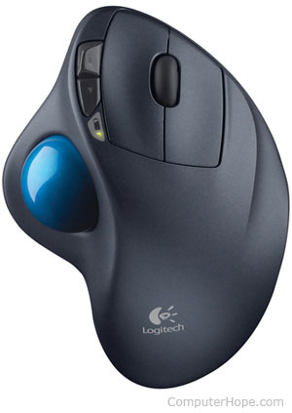
Below is a listing of all of the types of computer mice and pointing devices used with a computer. Today, for a desktop computer the most common type of mouse is an optical mouse that connects to the USB port and known as a USB mouse. For laptop computers, the most common type of mouse is the touchpad.
- Cordless (Wireless)
- Footmouse
- IntelliMouse (Wheel mouse)
- J-Mouse
- Joystick
- Mechanical
- Optical
- Touchpad (Glidepoint)
- Trackball
- TrackPoint

Computer mouse ports
Today, most computer mice connect to a computer using a USB port. Below is a listing of all of the type of ports and wireless connections that a mouse is capable of using or has used in the past.
- Bluetooth
- Infrared
- PS/2 Port
- Serial Port
- USB

What are the parts of a computer mouse?
The parts of a computer mouse can vary by the type of computer mouse. Below is a general overview of the parts found on most computer mice.
Buttons
Today, almost all computer mice have at least two buttons, a left button and right button for clicking and manipulating objects and text. In the past, there have been mice with only one button. For example, many of the early Apple computer mice only had one button.
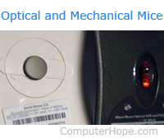
Ball, Laser, or LED
A desktop mouse may contain a ball and rollers if it is a mechanical mouse or a laser or LED if it is an optical mouse. Each of these components are used to track the movement and move the mouse cursor on the screen.
Mouse wheel
Today's desktop computer mice also usually include a mouse wheel that allows you to scroll up and down on a page.
Tip: Instead of rolling the wheel if you push in on the wheel it can be used as a third button.

Circuit board
To take all the signal information, clicks, and other information being created by the mouse and input it to the computer it must also have a circuit board with integrated circuits.

Cable or wireless receiver
For a corded mouse, it also includes a cable with a plug that connects to the computer. Today, most corded mice connect to the USB port. If your computer has a wireless mouse, it needs a USB wireless receiver to receive the wireless signal and input it into the computer.

Other parts
If you're using a laptop, some of the above components mentioned earlier are not required. For example, a touchpad does not use a ball, laser, or LED to control movement it uses your finger on the touchpad. Other parts include a ball for trackball mice, extra buttons that may be on the thumb side of the mouse, and nubs that may be used with other laptop mice.

What does a laptop use for a mouse?
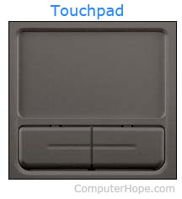
Because a laptop is designed for portability almost all laptops today use a touchpad as the mouse, and some Lenovo laptops still use a TrackPoint. Also, all laptop computers can have a USB corded or wireless mouse also attached to them.

What does a smartphone or tablet use for a mouse?
Smartphones and tablets use a touch screen as their primary input device, and therefore your finger is the mouse on these devices. With most tablets, you also have the option to connect a computer mouse and use it on the tablet.

What hand should I use to control the mouse?
By default, a computer mouse is setup to be used with your right-hand. However, if you are left-handed, it can be setup to be used with your left-hand.
Note: Although any mouse can be setup to be used with your left-hand keep in mind that some mice are molded to fit a right-hand and may feel uncomfortable with your left-hand.

How can I use or practice using the mouse?
Below is a page we've created that explains all of the basics of the mouse, how it's held, how to connect it, and how to use it on your computer. Included in the page is interactive examples that can be used to help practice with additional information about each of the mouse features.

Mouse vs. mice or mouses
When talking about one (singular) you refer to a computer mouse as a "mouse." When talking about two or more (plural), you refer to them as "mice" or "mouses" although "mice" is more standard.
Note: To help prevent confusion, some companies and writers avoid using either plural form of a mouse by referring to multiple mice as "mouse devices."

Is "mouse" an acronym?
No. Some believe that mouse is short for "manually-operated user-select equipment." However, when Douglas Engelbart helped invent the mouse, he called it a mouse because the device resembled the rodent.
Most computer users don't take full advantage of the computer Mouse. Below are computer mouse tips and secrets that help you get the full potential of your computer mouse and increase your overall productivity while on the computer.

Shift key and mouse click
Many text editors and programs allow you to highlight all or portions of text using the Shift key and the mouse. For example, click at the beginning of the text in the below text box. Hold down the Shift key, scroll to the bottom, and click at the end of the text to highlight all of the text.

Bonus Tip: Holding down the Alt key while dragging and highlighting text in a text editor allows you to selectively highlight text. Highlighting text this way is useful if the paragraph or other text is in a column. Note: This tip does not work in the above box and has to be done in a text editor or word processor.

Take full advantage of the scroll wheel
Today, everyone is familiar with a mouse wheels ability to scroll up and down on a page. However, this wheel can also do so much more, below are just a few examples.
- The mouse wheel is not just a wheel. It can also be used as a button. Pressing down on the wheel will acts like a third mouse button. The wheel button can be used to open a web page in a tab by clicking the wheel on any link and can also be used to close a tab by clicking the wheel on any open tab.
- Zoom in and Out on a web page, word document, excel spreadsheet, etc. by holding down the Ctrl key and scrolling up to zoom in and down to zoom out.
- Hold down the Shift key and scroll down in most Internet browsers to go back to the previous web page.
- Some mouse wheels can be pushed left or right to also move back and forward between web pages.

Select with double and triple click
Any word can be selected by double-clicking the word. If you want to highlight the whole paragraph or sentence, click the mouse button three times on any word. Try it now on this paragraph by clicking three times fast on any word in the paragraph.

Use the right-click
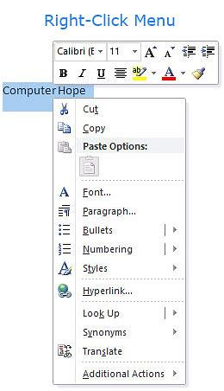
Take full advantage of the right-click any time you highlight text or want to view the properties of an object. For example, if you highlight a file or text, you can right-click that highlighted item, copy it, and then right-click anywhere else to paste it.
Bonus Tip: If you highlight or select any file or text and then click and drag while holding the right mouse button, when you let go an option to move or copy that file is shown. This saves you the extra step of having to right-click where you want to paste the item.
Bonus Tip: While in a browser, pressing and holding Ctrl while clicking on any link opens a menu with options for that link.

Ctrl key and mouse click or highlight
While holding down the Ctrl key, you can left-click to select multiple objects or highlight multiple sections of text. For example, in the below selection box, if you wanted to highlight more than one of the items listed, you could hold down Ctrl and select each item you want highlighted.

Use the mouse side buttons
Many new computer mice also have buttons on the side of the mouse. These buttons can be programmed to do anything. However, by default, the left-thumb button can be used to go back on a web page. Using the thumb button makes browsing the Internet more efficient since you do not need to move the mouse cursor to the browser's back arrow button to go back a page.

Use the Windows Snap To feature
Take full advantage of the Windows mouse Snap To feature, which will automatically move your mouse to buttons that appear in a dialog box. For example, if you delete a file or close a window, you may get a prompt asking you if you are sure you want to perform the task. With the Snap To feature enabled, the mouse cursor automatically moves to the Ok button, so all you have to do is click the left mouse button if you agree. This saves you the time of having to move the mouse cursor to the Ok button and then click Ok.
To enable this feature, open the Mouse properties under the Windows Control Panel and check the Snap To check box under the Pointer Options tab.
Bonus Tip: While changing this feature, we also suggest looking at other available options in the Mouse properties. For example, increasing the Motion speed can also help increase your productivity while using the mouse.

Manage the open window with the mouse
Double-click the top title bar of any window to maximize a window or, if it is already maximized, resize it to a smaller window. You can also double-click the icon for the window in the top-left corner of the window to close that window.

Move the mouse with your keyboard
Instead of using the mouse that came with your computer, you can also enable Windows to use the number pad as a mouse.

Customize your mouse
Finally, if you have a mouse with more than two buttons, installing the included mouse software allows you to customize the mouse even more. For example, if you don't use the side buttons to move back and forth in a web page, change it to something you do more often, such as switching between open windows or opening the calculator.

MONITOR
A monitor may refer to any of the following:
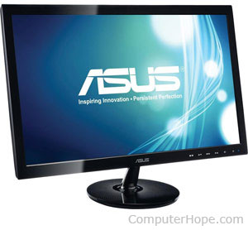
Alternatively referred to as a video display terminal (VDT) and video display unit (VDU), a monitor is an output device that displays video images and text. A monitor is made up of circuitry, a screen, a power supply, buttons to adjust screen settings, and casing that holds all of these components. Like most early TVs, the first computer monitors were comprised of a CRT (Cathode Ray Tube) and a fluorescent screen. Today, all monitors are created using flat panel display technology, usually backlit with LEDs. The image to the right shows an ASUS LCD monitor.

When was the first computer monitor invented?
The first computer monitor was part of the Xerox Alto computer system, which was released on March 1, 1973.

Why is a monitor an output device?
A monitor is only used to display (output) information from a computer and provides no source of input. For this reason, a computer monitor is considered an output device.

Types of monitor connections
Computer monitors have at least one of the following types of monitor connectors to connect to a computer.
- DVI
- HDMI
- VGA
Video adapters are available to convert from one type of connector to another, such as DVI to VGA or HDMI to VGA, and vice versa.

Monitor Description
Monitors are display devices external to the computer case and connect via a cable to a port on the video card or motherboard.Even though the monitor sits outside the main computer housing, it is an essential part of the complete system.Monitors come in two major types - LCD or CRT, but others exist too, like OLED. CRT monitors look much like old-fashioned televisions and are very deep in size. LCD monitors are much thinner, use less energy, and provide a greater graphics quality. OLED is an improvement on LCD that provides even better color and and viewing angles but also requires more power.
LCD monitors have completely obsoleted CRT monitors due to their higher quality, smaller "footprint" on the desk, and decreasing price. OLED, although newer, is still more expensive and therefore not as widely used when it comes to monitors in the home.Most monitors are in a widescreen format and range in size from 17" to 24" or more. This size is a diagonal measurement from one corner of the screen to the other.Monitors are built-in as part of the computer system in laptops, tablets, netbooks, and all-in-one desktop machines. However, you can buy one separately if you're looking to upgrade from your current monitor.
Although monitors are considered output devices since they usually only serve the purpose of outputting information to the screen, some of them are touch screens as well.This type of monitor is considered both an input and output device, which is usually called an input/output device, or an I/O device.
Some monitors have integrated accessories like a microphone, speakers, camera, or USB hub.

More Information on Monitors
Are you dealing with a monitor that isn't showing anything on the screen? Read our guide on How to Test a Computer Monitor That Isn't Working for steps that involve checking the monitor for loose connections, making sure the brightness is properly set, and more.Newer LCD monitors should be cleaned with care and not like you would a piece of glass or older CRT monitor.If you need help, see How to Clean a Flat Screen TV or Computer Monitor.
Read How to Fix Discoloration & Distortion on a Computer Screen if your monitor doesn't seem to be displaying things like it should, like if the colors seem off, the text is blurry, etc.
If you have an older CRT monitor that has a problem displaying colors, like if you see an array of colors around the edges of the screen, you need to degauss it to reduce the magnetic inference that's causing it. See How to Degauss a Computer Monitor if you need help.
Screen flickering on a CRT monitor can be solved by changing the monitor's refresh rate.
Monitors are usually instantly available through plug and play. If the video on the screen doesn't appear as you think it should, consider updating the video card driver. See How to Update Drivers in Windows if you need help.
The performance of a monitor is usually determined by a number of factors and not just one feature like its overall screen size, for example. Some of these include the aspect ratio (horizontal length against the vertical length), power consumption, refresh rate, contrast ratio (ratio of the brightest colors vs the darkest colors), response time (the time it takes a pixel to go from active, to inactive, to active again), display resolution, and others.

METHODS OF TYPEWRITING

Sight Method of Typewriting

The sight method was the only prevalent method right from the very beginning when the first typewriter was invented in 1714 till 1878, when another method of typewriting called as ‘Touch Method of Typewriting’ was introduced by an American Typist Mr. Charles McGurin.In the Sight Method the Typewriting is done by looking at the Keyboard and the material which is to be typed by the Operator. The Operator reads a few words from the matter to be typed, types the same by looking at the Keyboard and then again reads some words and types them again and goes on repeating this process till the whole page is typed. In this method all the fingers are not used. Only the ‘forefingers’ of both the hands are used for typing in the sight method of typewriting. This method is not scientific. In this method the Operator cannot concentrate on the copy. Though this system is easy to learn in the beginning, but it is not good for acquiring high speed in typewriting.

Advantages of Sight Method of Typewriting

- It is very easy because it can be learnt without the help of a teacher.
- There is no need to learn and master the Keyboard.
- It is beneficial for those who have to use the computer for their personal
use because they are not required to learn the operation of the Keyboard.

Disadvantages of Sight Method of Typewriting

- Since typewriting is done only with two fingers of both the hands, more
time and energy is spent for typing little amount of work.
- The Computer Operator gets tired by using this method because of the
frequent movement of eyesight both on the Keyboard and the matter to
be typed.
- High speed cannot be attained.
- There are chances of omission of words/lines, because the Computer
- Operator has to look both on the copy from where the matter has to betyped and the Keyboard for locating the alphabets and in doing so, omissionsare possible.
- All the fingers of both the hands are not used in this method.
Touch Method of Typewriting

Touch means the operation of the Computer without looking at the Keyboard. The Computer Operator has to keep his eyesight only on the note book from which the matter has to be typed. The operation of the Keys is by sense of location and not by sight. This method is based on scientific lines. Each finger has to operate on the keys allotted to it. All the fingers of both the hands are used in this method. Unnecessary movement of eyesight and hands is avoided. This is the most scientific and modern method of typewriting. In this method, generally, the keyboard is first divided into two parts, one for the left hand, and the other for the right hand, each part being sub-divided into sections for each finger. The ‘Forefingers’ of both the hands are allotted eight keys each because these fingers are stronger than the other fingers.Touch method of typewriting is superior to the sight method. Though in the beginning the Computer Operator has to put in hard work, but it is very beneficial for acquiring high speed in the long run.

Advantages of Touch Method of Typewriting

- There is saving of time and energy. Since the work is distributed amongst
all the fingers of both the hands and unnecessary movement of hands and
eyesight is avoided, the matter can be typed quickly. This can be specified
as division of labour among all the fingers.
- High and accurate speed can be attained.
- The Computer Operator does not tire even after many hours of workbecause the work is divided among all the fingers of both the hands.
- Since the eyesight remains on the matter to be typed, there are less chancesof omission of words or lines. Unnecessary movement of eyesight is alsoavoided.
- The Operator is not required to look at the Keyboard.
- The Operator can concentrate very well on the matter to be typed.
- Rhythm is maintained in this method of typewriting.

POSITION OF FINGERS

Where should fingers be placed on the keyboard?
As you can see in the picture below, your left-hand fingers should be placed over the A, S, D, and F keys and your right-hand fingers should be placed over the J, K, L, and ; keys. These keys are considered the home row keys. Your thumbs should either be in the air or very lightly touching the spacebar key.
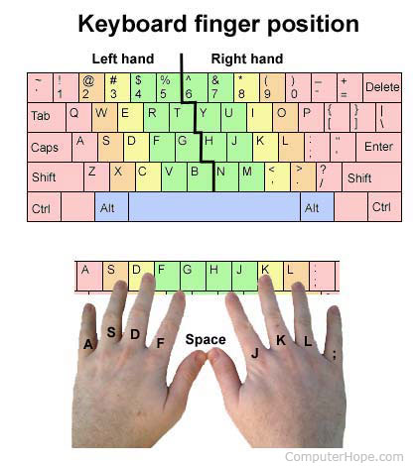

What fingers press each key on the keyboard?
In the table below, we've listed the home row keys in the top blue bar and each of the keys that finger presses, as well as the keys that the thumb (spacebar) presses. As seen in this table, both pinkies, especially the right-hand pinky, are responsible for the most keys on the keyboard.
The remaining keyboard keys not listed above are not necessarily assigned to a specific finger for pressing them. Instead, you can use whichever finger is easiest or most comfortable for reaching and pressing those keys.
Note: For keys with two or more characters you may need to use two hands and two fingers to create the character. For example, with the bracket and brace key ( [ { and ] }) to type the curly bracket you must press the left Shift key with your left-hand pinky and then the open or close bracket with your right-hand pinky.

How many fingers should be on the home row?
With the four fingers on both hands on the home row there should be a total of eight fingers on the home row.

Should my palms be resting or should they be raised?
When typing, your palms should be raised and not resting on any surface, including a wrist pad, and held at a 10 to 30-degree angle. Raising or lowering your wrists too much in either direction or resting them while typing can cause stress and may lead to carpal tunnel.

Other keyboard safety tips
While keeping your palms raised while typing, there are also other tips you can follow to help prevent carpal tunnel and pain while you type. Keep the below suggestions in mind every time you type.
- Keep your keyboard home row height as close to elbow level as possible.
- Center the spacebar with your body.
- Do not angle or bend your wrists. While typing keep your wrists elevated as straight as possible.
- Avoid hunt-and-peck typing as it causes strain on the neck from having to look down at the keyboard often.
- Don't use more force than needed to press the keys.
- When you are not typing make sure to rest your arms and hands. However, never rest your arms, hands or wrist on a sharp edge.
- Take a break from typing every 20 to 30 minutes. If you have a hard time remembering when to take a break set a timer or drink lots of water that forces you to go to the bathroom more often.

UNIT-IV

USE OF TOUCH TYPING TUTOR SOFTWARE
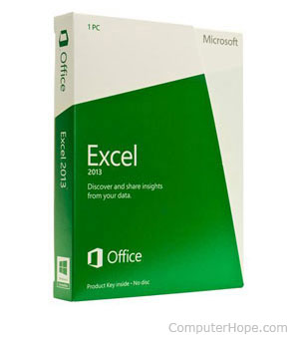
Sometimes abbreviated as SW and S/W, software is a collection of instructions that enable the user to interact with a computer, its hardware, or perform tasks. Without software, most computers would be useless. For example, without your Internet browser software, you could not surf the Internet or read this page and without an operating system, the browser could not run on your computer. The picture to the right shows a Microsoft Excel box, an example of a spreadsheet software program.
- Examples and types of software
- How do you get software?
- How do you use computer software?
- How to maintain software
- How is software created and how does it work?
- When I save a document, is that file also considered software?
- What was the first piece of computer software?
- Related software pages.
- Software help and support.

Examples and types of software
Below is a list of the different kinds of software a computer may have installed with examples of related programs. Click any of the links below for additional information. It should be noted that although software is thought of as a program, it can be anything that runs on a computer. The table below also includes a program column to clarify any software that is not a program.
Software | Examples | Program?
Antivirus | AVG, Housecall, McAfee, Norton | Yes
Audio / Music program | iTunes, WinAmp | Yes
Database | Access, MySQL, SQL | Yes
Device drivers | Computer drivers | No
E-mail | Outlook, Thunderbird | Yes
Game | Madden NFL Football, Quake,World of Warcraft | Yes
Internet browser | Firefox, Google Chrome, Internet Explorer | Yes
Movie player | VLC, Windows Media Player | Yes
Operating system | Android, iOS, Linux, macOS, Windows | No
Photo / Graphics program | Adobe PhotoShop, CorelDRAW | Yes
Presentation | PowerPoint | Yes
Programming language | C++, HTML, Java, Perl, Visual Basic (VB) | Yes
Simulation | Flight simulator, SimCity | Yes
Spreadsheet | Excel | Yes
Utility | Compression, Disk Cleanup,Encryption, Registry cleaner | No
Word processor | Word | Yes

How do you get software?
Software can be purchased at a retail computer store or online and come in a box containing all the disks (floppy diskette, CD, DVD, or Blu-ray), manuals, warranty, and other documentation. Software can also be downloaded to a computer over the Internet. Once downloaded, setup files are run to start the installation process on your computer.
Free software
There are also millions of free software programs available that are separated into different categories.
- Shareware or trial software is software that gives you a few days to try the software before you have to buy the program. After the trial time expires, you'll be asked to enter a code or to register the product before you can continue to use it.
- Freeware is completely free software that never requires payment, as long as it is not modified.
- Open source software is similar to freeware. Not only is the program given away for free, but the source code used to make the program is as well, allowing anyone to modify the program or view how it was created.

Freeware
Alternatively referred to as free software, freeware is software that is made available 100% free as long as it remains un-modified. The complete opposite of freeware is commercial software. Unlike open-source software, freeware cannot be modified and is often only licensed to be used by non-commercial users.

OSS
OSS may refer to any of the following:
.
1. Short for Open-Source Software, OSS is a software source code that is freely distributed to help develop the software or allow for customization with the software. Perl is a good example of an OSS software program. Unlike freeware, Open-Source software allows any user to modify the code.
2. Short for Operations Support Systems, OSS are automated systems developed by the telecommunications industry to assist customers with services such as billing and maintenance.
Software

Mavis Beacon Teaches Typing. No list of typing tutorials would be complete without this well-known software used in many schools and homes to improve typing skills. This program includes a number of speed tests and constantly
tracks the user's words-per-minute typing speed. A certificate of achievement canbe printed by the user upon the completion of tests. These certificates allow students to see their best typing abilities along with the areas that truly need some help. It also includes a number of typing games.

Microsoft Solitaire
One of the very best ways to learn to use the mouse is by practicing, and – lucky for us playing a game like Microsoft’s Solitaire is one of the best ways to practice! Solitaire is probably already on your computer. If you’re in the literacy computer
lab or in the library, ask a staff member to help you find the software and start a game. Otherwise, go to “Start” then “Games” and then select Solitaire. At first
you will need coaching but soon enough you will be able to play this game
on your own.

Typing Instructor Deluxe 17.
Like Mavis Beacon, Typing Instructor Deluxe 17 software motivates you to improve your typing speed and accuracy using amazing graphics and fun challenges. It also suggests lessons, tests, strengthening exercises, practice material, and typing games for your skill level. It even comes with a keyboard key cover so you won’t be tempted to peak as you’re learning! Books Mastering Computer Typing: A Painless Course for Beginners and Professionals (Spiral Bound Book). User-friendly exercises and practice lessons to build up speed and efficiency.

Designed for individual or classroom use in a handy spiral-bound format, Mastering Computer Typing is the perfect tutor or guide for anyone who needs to learn to touch-typeon a computer keyboard. WebsitesHere are a few of the outstanding online resources that provide opportunities to practice typing
and use the computer keyboard and mouse while learning about reading, writing, etc.

Fowl Words – www.primarygames.com/langarts/fowlwords/index.htm
Want some practice with your keyboard and mouse while you see how many words are in your vocabulary so far? Then, take a break from the serious stuff and give this game a try!

Grammar Bytes –www.chompchomp.com
GOAL: Learn to Type & Use the Computer Keyboard (& Mouse) 5 Instead of just talking about rules of grammar, use these exercises to reinforce the rules AND get in a lot of mouse exercise as well.

KeyBlaze Typing Tutor–www.nchsoftware.com/typingtutor/index.html
KeyBlaze is a free typing tutor software program that allows you to start
with basic lessons and then move on to practice lessons including poetry, prose and drills. KeyBlaze also features a typing test. The small program downloads quickly, creating a shortcut on your desktop. It has a simple interface—very easy to use.

Learning Express Library – www.learnatest.com/lel
This online course is available from any computerconnected to the Internet. All you need is your library card number to register. It was created by certified instructors specifically for users who are new to Microsoft Word. It includes hands-on practice, interactive content, step-by-step instruction with audio, plus other great features designed to make learning the basics of the program effective and easy, all at your own pace. New users: Click “Register,” choose the “Computer Skills”
learning center, Microsoft Word course, Course 1, Basic.

LearningLadder –www.learningladder.org/basics
You’ll find a Computer Basics learning module here that covers (among other things) the mouse, keyboard, and word processing. Good stuff!

MakeBeliefsComix–www.Makebeliefscomix.com
A great way to let creative juices flow—and to practice typing and writing skills—while you try your hand at creating your own comic strips!

Mousing Around–www.pbclibrary.org/mousing/intro.htm
If you’re totally new to computers, you really should check out one of the very best tutorials out there – the Mousing Around tutorial. This surprisingly entertaining tutorial begins with the most very basic information about the mouse, and builds on each step, ultimately giving you the ability to use your computer with much more confidence. Try it!

Powertyping – www.Powertyping.com
Not necessarily a pretty site – and probably more for “kids” under 30 – but there could hardly be a more fun way to practice typing faster ... and faster ... and faster ..

Puzzler-Maker –www.Puzzler-maker.com
Although you cannot actually DO the puzzle online (unless you buy the software), it is still a fun exercise as you type words and clues to create your own puzzles.
Then, just print the puzzle to fill out later.

Typing Master Games – www.typingmaster.com/games/typing-games.asp
These two games can be challenging and addictive, but either way, you’ll learn while you play. In Key Man you’ll type changing letters to guide Key Man through the maze. Eat all the energy pills while avoiding the evil typo ghosts. The other game is called Bubbles, and in this underwater typing game your goal is to burst the bubbles before they reach the surface of the sea.

RAPID TYPING TUTOR
Rapid Typing Tutor is a typing program for Windows computers that helps you learn how to type, no matter what type of keyboard format you have. Learning how to type can be a bit of an overwhelming experience for newcomers. Most keyboards aren't set up alphabetically, so its format may seem complicated for those unfamiliar with it. Rapid Typing Tutor is there to help though. Whether you have a regular QWERTY keyboard or something a little less traditional, Rapid Typing Tutor probably has your keyboard format saved and available to use for typing lessons. The lessons also come in a great variety of different languages besides English. Once you've chosen your keyboard and language settings, it's time to choose the lesson most appropriate for your skill level. Rapid Typing Tutor has everything from the most basic lessons to more advanced ones. You can choose to take lessons that teach you where specific letters are or lessons that teach you how to type different word sets.
Rapid Typing Tutor's set-up is quite convenient, as it offers a virtual keyboard, complete with a pair of hands that show you the appropriate placement for your hands on your own keyboard. Then, just follow the on-screen instructions. Rapid Typing Tutor will make a noise if you hit an incorrect key. If this becomes distracting, there is an option to mute the program. If you'd like a more scenic screen while learning how to type, Rapid Typing Tutor also offers an animated screen that moves forward every time you click the correct letter. The only real hang-up a user might have with Rapid Typing Tutor is that the program does take up quite a lot of space on your screen. It also sometimes freezes up for a moment or two between screens, particularly when you have several programs running at once. If you want to learn how to type at a quicker speed, however, give Rapid Typing Tutor a try.
Rapid Typing Tutor is a typing program for Windows computers that helps you learn how to type, no matter what type of keyboard format you have. Learning how to type can be a bit of an overwhelming experience for newcomers. Most keyboards aren't set up alphabetically, so its format may seem complicated for those unfamiliar with it. Rapid Typing Tutor is there to help though. Whether you have a regular QWERTY keyboard or something a little less traditional, Rapid Typing Tutor probably has your keyboard format saved and available to use for typing lessons. The lessons also come in a great variety of different languages besides English.
Once you've chosen your keyboard and language settings, it's time to choose the lesson most appropriate for your skill level. Rapid Typing Tutor has everything from the most basic lessons to more advanced ones. You can choose to take lessons that teach you where specific letters are or lessons that teach you how to type different word sets. Rapid Typing Tutor's set-up is quite convenient, as it offers a virtual keyboard, complete with a pair of hands that show you the appropriate placement for your hands on your own keyboard. Then, just follow the on-screen instructions. Rapid Typing Tutor will make a noise if you hit an incorrect key. If this becomes distracting, there is an option to mute the program. If you'd like a more scenic screen while learning how to type, Rapid Typing Tutor also offers an animated screen that moves forward every time you click the correct letter. The only real hang-up a user might have with Rapid Typing Tutor is that the program does take up quite a lot of space on your screen. It also sometimes freezes up for a moment or two between screens, particularly when you have several programs running at once.
If you want to learn how to type at a quicker speed, however, give Rapid Typing Tutor a try.

Get it Free. Download the free version of KeyBlaze here to improve or start learning how to type now. You can always upgrade later for additional typing lessons, professional exercises and other custom features.

TYPEWRITING SPEED AND ACCURACY

LET’S START
Now you may be anxious to develop your speed and simultaneously to have the accuracy in e-typewriting. In this lesson you will learn the means to attain accuracy as well as to develop your speed. You will be able to identify the mistakes/errors to be penalized for the purpose of calculation of your running and accurate speed. In the previous lesson you have learnt about e-Typewriting ergonomics. In that lesson you have attained the mastery of the keyboard operations.
OBJECTIVES
After going through this lesson you will be able to:
•develop your speed and accuracy in e-Typewriting
•concentrate your mind on the text to be typed
•know the rules of spacing in punctuation marks
•identify the errors liable to be penalized for calculation of speed.
•rectify the errorsAfter completing this lesson you will be able to attain the following.

DEVELOPMENT OF TYPEWRITING SPEED AND ACCURACY

By typewriting speed we mean the number of words typed per minute. Now
you will learn how to develop, i.e., increase your typewriting speed with
accuracy. You are advised to bear in mind the following tips to develop your
typewriting speed and accuracy:

1. You should have confidence and concentration for success in touch
method of typewriting.
2. Remember the three golden rules – practice, practice and practice.
3.You should correlate your reading speed with typewriting speed.
4.While typing the small words such as on, to, the etc. should be read as a
unit whereas long words such as occasional, performance, psychological
should be read character by character.
5.If the computer is faulty, sluggish, or irresponsive it is impossible toattain the
good speed. The computer should be in good condition.
6.Correct ergonomics also play an important part in attaining high speedandaccuracy.
7. You should have adequate knowledge of rules of spacing before andafter punctuation signs. Before starting daily routine practice you are requiredto exercise your fingers on all the 26 alphabets. For such an exercise, thefollowing sentences are of much help:

1.The quick brown fox jumps over the little lazy dog.
2.If you are ambitious and enthusiastic, you will be able to succeed in
joining the company of experts who have become wizards of the keeps.
3.Just as was generally expected, the lazy boy failed to answer the five
questions asked from him.
4.Accuracy and speed in the vocation of the typewriting on computer may
be acquired by judicious work and zealous effort.
5. Examination and inquiry will enable us to form round judgments and
help us to realize that we must speak very exactly.

Typewriting Speed and Accuracy :: 51

1. Instructions for speed and Accuracy Development (Mental exercises)—

(i) Until you are able to type with perfect mental control, you cannot attain speed with perfect accuracy. Accuracy comes first and speed comes later while both are inter-linked. By reading accurately you will get accurate speed. Concentrate your mind on the characters and punctuation marks to be typed and read rhythmically. The action of figures should go on line with reading and not read in advance to the action. The increase in speed should be gradual and be raised only when reading, concentration and action of the fingers are properly controlled.

(ii) If you read the text methodically and character-by-character, thebrain is able to direct the fingers properly and no chance for anyerror.

(iii) For adjustment keys use only the finger near to them. The light touch of key give more speed and greater stamina for work. Never look at the keyboard which merely wastes time and invites errors.

(iv) While taking speed test do not loose your power of concentration
which makes you nervous and disturbs continuity which is essential to attain the speed. Before beginning the test you should see that the computer is in perfect working order, all adjustment keys are correct and the mechanism is working properly.

(v) Before taking speed test leave top margin of 2.5 cms and 5 or 7 spaces from the left set margin in the first line of each paragraph for Identation of new paragraphs.

(vi) Typewrite only in double-line space and be careful for punctuation marks, syllabification and accuracy.

2.Essentials for speed development are:

1.Physical fitness
2.Correct posture
3.Knowledge of the keyboard
4.Proper technique
5.Smooth, even stroking
6.Quick, but precise key stroke
7.Efficient fingering ability
8.Ease of operation
9.Ability to relax
10.Mental control

What is an Average Typing Speed?

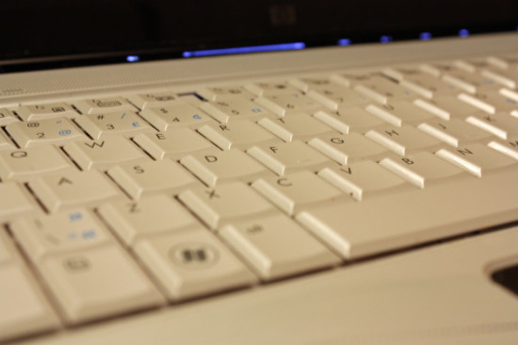
For those who are just beginning to type, they are often interested in the answer to the question, “what is an average typing speed?” The average typing speed is 36 words per minute. Typing speed is usually measured in words per minute, but as most people have noticed, words have different lengths. Depending on your profession, you may need to type longer words than in other professions. For example, if you’re a legal typist, you’re probably typing longer words than most people do. For this reason, the best way to measure typing speed is in characters per minute. The average typing speed, in this case, is about 187 characters per minute.

What’s a good typing speed?
A good typing speed for most people is 40 words per minute or over. This would give you a word count of 2400 words per hour if you could sustain the pace for sixty minutes. There are people who can type a whole lot faster than 40 words per minute. If you’re a professional typist, you can probably type 75 words per minute, and maybe even more. What’s the world record? Believe it or not, it’s 150 words per minute, and that was measured over a sustained period. When given a shorter time frame, our world-record typist could reach a speed of 212 words per minute. In other words, she can type much faster than most people can talk.

How can I improve my typing speed?
Have a good keyboard: Improving your typing speed takes practice and good equipment. If you have to hammer certain keys a few times before they registered, it’s obviously going to take you longer to type than if you have equipment which performs well. If you spend a good portion of your day on the computer, it’s worth investing in a good keyboard.
Learn how to touch type: Touch typing means that you don’t have to look at your keyboard when you’re typing words. You just monitor your screen as you type. Touch typing also means using both hands and all of your fingers. If you are someone who one or two-finger types, you’ll never be in a position to be a quick typer. Luckily, you don’t have to sign up for expensive lessons: there are plenty of free touch typing games and apps available. Simply do a search for “free online touch typing” and you should have plenty of resources from which to choose/
Posture is important: You may find that you need to alter the height of your chair to get into a correct typing posture. Experts say that you should be able to sit up straight and that your elbows should be bent at a 90-degree angle. Your wrists can rest lightly on the table, but don’t put weight on them. When your fingers hover over the ‘home row’ – the middle row of letters, they should be slightly bent.
Use your keyboard shortcuts: Copying, pasting, undoing or finding a word in your text can easily be done with a few simple keyboard shortcuts. There’s no need to use your mouse. Since your fingers are already busy on your keyboard, learning your shortcuts will help to save you time.
Practice, practice, practice: Practice, as they say, makes perfect. So the more you practice your touch typing, the faster you’ll get. Spend half an hour to an hour on practice every day, and you’ll be amazed at how quickly your typing speed can improve!
Take your time: It’s worth taking your time to learn accuracy rather than rushing to complete as many words per minute as possible before returning to correct them. Corrections take up time, so getting things right the first time around will help you to improve your overall speed. You’ll still have to check your work, but if you follow the rules of touch typing and keep your eyes on the screen, there shouldn’t be much to correct.
Improving your typing speed will make you more productive and will help you to capture your thoughts before the inspiration disappears.

How typing speed and accuracy is calculated in typing tests

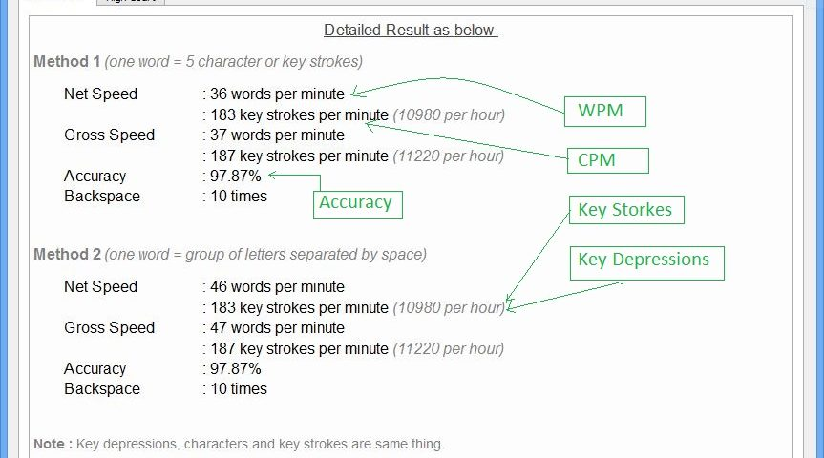
Typing speed can be calculated in various ways. Every typing test examination has its own ways how it measures typing speed and accuracy. It completely depends on the recruiter board or commission which is organizing the typing test.
In this post I am going to discuss how most typing tests calculate typing speed like typing tutor software including Soni Typing Tutor, online typing tests measure typing speed. These formulas are same equally applicable for both English typing and Hindi typing or any other language.

Calculation of typing speed
There are two types of speed one is net speed and another is gross speed. Net speed is the speed in which only correctly typed words and characters are considered for speed calculation. Gross speed includes incorrectly typed words and characters also. Incorrect typed words are used to calculate typing accuracy. We at Soni Typing Tutor focus on accuracy so forget the gross speed because it is not your actual speed. Always focus on your net typing speed and accuracy.
1. Characters per Minute (CPM)
Number of characters typed in a minute. Characters, key strokes, key depressions, letters are the same thing. Blank space, backspace, enter or other non – character letters are not counted as characters. To understand it in simple words you can consider a character which prints on your screen would be considered a character. Enter, blank space, backspaces do not print anything on computer screen.
For example the sentence “Soni typing tutor is trying it’s best to serve users” has 43 characters.
Note : characters which were the part of a word typed incorrect will not be included in calculation. For example the sentence “Soni typing tutor is trying it’s best to serve users” has 43 characters. If a person typed “Soni typing tutor is trying it’s best to severe users”. He typed severe instead of serve. So characters of word severe will not be counted this time because this word is incorrectly typed. So character count in this case is 38 characters only.
2. Words per Minute (WPM)
Number of correct Words typed in a minute is your speed in WPM. But the definition is not that simple at it appears. Real question is what a word is. Definition of word varies from examination to examination. There are two methods for words. Mostly words are counted by these two methods.
Method 1: Number of characters (without spaces) divided by 5. So group of five characters is counted as a single word. For example the sentence “Soni typing tutor is trying it’s best to serve users” has 43 characters. Suppose all the words are typed correct. then the number words of would be 43/5=8.6 words. Incorrect words are not counted.
Method 2: A word separated by space is counted as single word. For example the sentence “Soni typing tutor is trying it’s best to serve users” has 10 words.
3. Key Strokes per hour/ Key Depressions per hour(DPH):
Key strokes and key depressions are the same as characters per minute discussed above. Soni Typing tutor considers character, letter, key stroke and key depression same thing.
Character = letter= key stroke= key depression
The basic difference which should be noted is that the speed is measured for per hour not per minute. So your speed in this method is at per hour instead of per minute which was the case in the above two methods.

Calculation of typing accuracy
Accuracy is the percentage of correct words out of total typed words. It is calculated in percentage. Suppose you typed total 100 words in a typing test. You have typed 85 words correct and 15 words incorrect. Then your typing accuracy is 85%. In a test in which typing speed is calculated in characters per minute, keystrokes/key depression per hour, that case accuracy include the characters part of correct words. Characters which are part of a incorrect typed word will not be considered in calculation of accuracy.
Note: One must follow the instructions mentioned in the notification of his/her recruiting authority. Soni Typing Tutor shows detailed result using all the above methods in both English and Hindi Typing. English typing is absolutely free with Soni typing tutor. So just Download Soni Hindi Typing Tutor and English Typing Tutor for now for free and go ahead towards your success.

Average Typing Speed: Why Is Is Important?
Any information on typing always comes down to the same question: What are your average typing speed and your accuracy? Why is it so important, and why does everyone want to know? Below are a few facts about typing and hopefully, a few hints as to why average typing speed is so important.

The Highest Typing Speed
The fastest typist in the world was a woman named Barbara Blackburn. In 2005, using a Simplified Dvorak keyboard, she was able to sustain 150 words per minute for 50 minutes, and 170 words per minute for shorter amounts of time. She was even clocked at a peak speed of 212 words per minute. This is well above what a professional typist, using a QWERTY keyboard, will usually manage. 50 to 80 words per minute is around the average for professional typists, and should be what most people strive for if they type for a living.

Average Typing Speed Statistics
- As a general rule, girls like to type more than boys.
This may be for a variety of reasons. Boys, stereotypically, spend more time on multi player online games that require quick typing speeds in order to communicate with your teammates. The divide is not as high as you would think though, as approximately 45% of boys prefer typing, to 55% of girls. This is a statistic related only to touch typing, as there are high number of female dominated jobs that require typing skills, though not all of them require a high word per minute speed.
- Average one minute typing speed, for most casual typists, is around 41 words per minute, with approximately 92% accuracy.
To give this a bit of context, writing things by hand is usually around 31 words per minute for memorized material, or 22 words per minute for copied material. This is a good speed for someone who only types out the occasional email to family, or for someone whose livelihood doesn't depend on their speed at a keyboard. For anyone else, a regiment of practice should be employed to improve speed and accuracy.
- When it comes to any skill, the most important thing to remember is to practice.
I'll say it again, just for retention: Practice. You wouldn't sit down at a piano and expect to be a concert level pianist, and you shouldn't sit down at a keyboard and expect to be a competition level typist either. Spend 30 minutes or so each day practicing. If you're just beginning, or working on switching over from hunt and peck style typing, then start from the beginning and work your way up. If you've already got some decent touch typing skills, then work on accuracy and speed drills. Keep track of your efforts over the course of a few weeks and you will see marked improvement.
With touch typing, it is important to start young. Studies have shown that for people ages 18 and younger, it is two times easier to learn to touch type properly. It's no different than learning a new language and multiple studies have proven that children learn and retain new languages much easier than adults do. Teaching children how to properly touch type may be the most important skill you can give them to help them gain success in the work place.So why is your average typing speed and typing accuracy so important? The fact of the matter is that typing skills are the most important thing to learn, at any age, to make you a more coveted employee.
- Employers are more likely to hire an experienced touch typist than a hunt and peck typist, simply for efficiency. Do yourself a favor and learn the basics, if you don't already know them. You'll be surprised what a difference it makes. Test your typing speed in WPM here. After passing a test you will get a typing certificate that you may put in your resume.
- You will be able to finish your typing work faster no matter you are a student, at work or at home working as a freelancer writer.
- Touch typing can become your invaluable skill that you mastered in 2014. What are you waiting for? Practice
- Leaderboard
- How to type
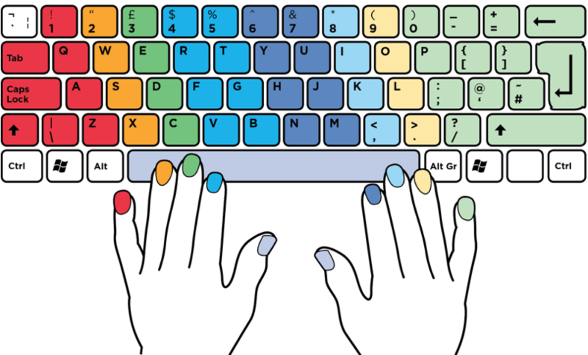
SAFETY AND SECURITY OF DATA

Data safety and security means ensuring that data is safeguarded from any
possible misuse and loss so that its integrity and confidentiality is maintained.Access of data is to be suitably controlled and privacy of data maintained.Thus, safety and security of data include:
•maintaining confidentiality of information and respecting privacy of users
•ensuring access control to only authentic users
•availability of data at a given time
•ensuring non-repudiation i.e. senders of messages cannot deny the fact.All potential threats which may violate safety and security of data are to betaken care of and prevented. If not prevented and unchecked, it may damageor delete data, spy on data, deliver unwanted data etc.

REMEMBER:COMMON THREATS TO A COMPUTER SYSTEM

•PC Intrusion (damaging resources of computer system)
•Computer Virus viz. Worms and Trojan Horses (codes which may
damage documents or files)
•Spyware (do spying and track user’s behavior)
•Password Hacking (guessing of password for unethical use)
•Phishing (acquiring of confidential information by fraudulent process)
•Spamming (sending of bulk mail by identified or unidentified source)
•Adware (delivering of unwanted data to a computer system)

Login Password, authentication and anti-virus software techniques arenormally used by administrators to ensure safety and security of data, whichare discussed below:Login PasswordThere can be different methods of logging in to a computer system and thatmay be via image, fingerprints, eye scan, password (oral or textual input),etc. With the help of Login Password, a user presents certain specificcredentials and then can have access to a computer system by identifying andauthenticating the same . It is a common practice to put a password protected screensaverwhich gets activated automatically after setting pre-defined period of inactivity. The screensaver is to be unlocked to gain accessto the system.

Authentication
It is the act of confirming the identity of a person or software program.Authentication is access control to a system and is supposed to be used onlyby authorized users and exclude the unauthorized. Common examples ofauthentication include password, photo ID, ATM, internet banking, etc.

Use of Anti-Virus

Anti-virus software is a software which is used to prevent, detect, and removeany malware threat and provide security to the computer system. Theexamples of malware are computer virus, spyware, Trojan horses, etc. whichmay corrupt the data and files of computer system. Various products andservices are available in the market to fight, prevent and remove malwarethreats. Anti-virus software can also predict what a file will do by analyzingwhat it does to see if it performs any malicious actions. It is common practiceto check external drives to detect any malware which may be present with ananti-virus software before copying or downloading the data from them.

DOs and DONTs:

SAFETY AND SECURITY OF DATA
•Download important data at the end of every day.
•Use anti-virus software.
•Thoroughly read agreements before installation of any software.
•Scan your computer system regularly.
•Keep your e-mail id confidential.
•Do not ignore security alerts.
•Block all Cookies.

Large companies are also using some of the following techniques to ensure
security of their data :
- Data Warehousing: Back up of all the important and useful data canbe saved in Data Warehouses. Use of Data Warehouses saves businessorganizations from huge data loss due to unforeseen circumstances viz.natural calamities, bomb blasts, accidents, mass data corruption etc.

b)Data Encryption: It means transforming plain text into coded formwhich is non-readable to a layman. Conversion of data into encryptedform while storing in the ‘Data Warehouses’ ensures safety of data. Ifanyone wants to use the data, the data stored is to be first decrypted byusing security password and a decoding algorithm. In this way, only theauthorized staff can have access to the data.

c)Data Masking: Data Masking of structured data is the process ofobscuring (masking) specific data within a database table or cell to ensurethat data security is maintained and sensitive information is not exposedto unauthorized persons.

